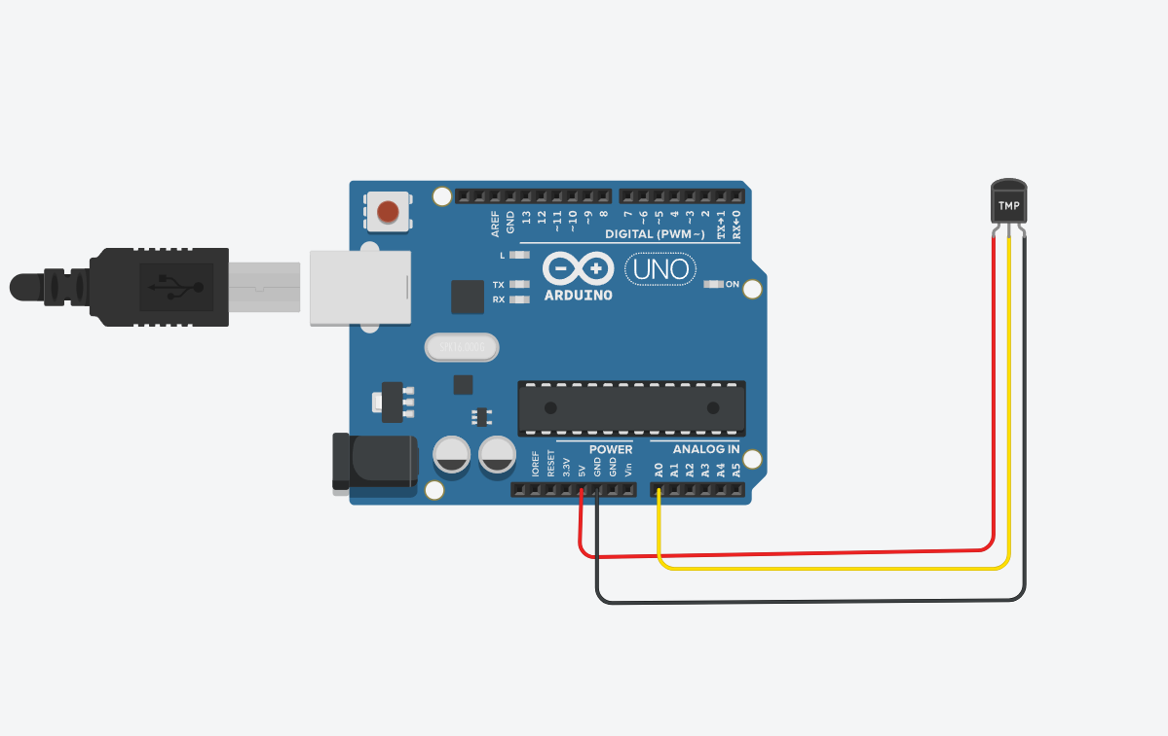

const int tempPin = A0 ; // TMP36 output connected to A0

void setup() {

Serial.begin(9600);

}

void loop() {

int sensorValue = analogRead(A0);

float voltage = sensorValue \* (5.0 / 1023.0); // Convert analog value to voltage (0V to 5V)

float temperatureC = (voltage - 0.5) \* 100.0; // TMP36 offset correction

Serial.print("Temperature: ");

Serial.print(temperatureC);

Serial.println(" °C");

delay(1000); // Update every 1 second

}